**Indexer**

How is the search request latency of your solution affected by the size of the index table?

As number of html documents generated by crawler increase the index table increases.

If number of html documents generated by crawler increased to **5**

The execution time of indexer will be

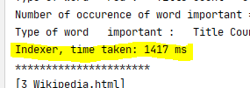

If number of html documents generated by crawler increased to **20**

The execution time of indexer will be



If number of html documents generated by crawler increased to **50**

The execution time of indexer will be

